Lecture 13
CO1: Apply the knowledge about the concepts of probability and statistics for the computer applications.
CO2: Evaluate the ideas of probability and random variables and various discrete and continuous probability distributions and their properties.

DISCRETE PROBABILITY DISTRIBUTIONS
All possible values of a discrete random variable together with their probabilities of occurrence. It is called a discrete probability distribution. There are two kinds of distributions in the discrete probability distribution.
i) Binomial Distribution, and
(ii) Poisson Distribution.
Let us discuss these two distributions in detail
Binomial Distribution
It is the basic and the most common probability distribution. It has been used to describe a wide variety of processes in business. For example, a quality control manager wants to know the probability of obtaining defective products in a random sample of 10 products. If 10 per cent of the products are defective, he/ she can quickly obtain the answer, from tables of the binomial probability distributions. It is also known as Bernoulli Distribution, as it was originated by Swiss Mathematician James Bernoulli (1654-1705).
The binomial distribution describes discrete, not continuous, data resulting from an experiment known as Bernoulli Process. Binomial distribution is a probability distribution expressing the probability of one set of dichotomous alternatives, i.e., success or failure.
As per this distribution, the probability of getting 0, 1, 2, …, n heads (or tails) in n tosses of an unbiased coin will be given by the successive terms of the expansion of (q + p)^{n} , where p is the probability of success (heads) and q is the probability of failure (i.e. = 1- p).
Binomial law of probability distribution is applicable only when:
a) A trial results in either success or failure of an event.
b) The probability of success ëpí remains constant in each trial.
c) The trials are mutually independent i.e., the outcome of any trial is neither affected by others nor affects others.
Assumptions
i) Each trial has only two possible outcomes either Yes or No, success or failure, etc.
ii) Regardless of how many times the experiment is performed, the probability of the outcome, each time, remains the same.
iii) The trials are statistically independent.
iv) The number of trials is known and is 1, 2, 3, 4, 5, etc.
Binomial Probability Formula:
P(r) = ^{n}C_{r} p^{r} q^{n-r}
where, P (r) = Probability of r successes in n trials;
p = Probability of success;
q = Probability of failure = 1 - p;
r = No. of successes desired; and
n = No. of trials undertaken
The determining equation for ^{n}C_{r} can easily be written as:
^{n}C_{r} = $\frac{n!}{r!\left(n-r\right)!}$
n! can be simplified as follows:
n! = n (n-1)! = n (n-1) (n-2) ! = n (n-1) (n-2) (n-3) ! and so on.
Hence the following form of the equations, for carrying out computations of the binomial probability is perhaps more convenient.
$$P(r) = \frac{n!}{r!\left(n-r\right)!} p^{r} q^{n-r}$$
The symbol ! means factorial, which is computed as follows: 5! means 5 × 4 × 3 × 2 × 1 = 120. Mathematicians define 0! as 1.
If n is large in number, say, ⁵⁰C₃, then we can write (with the help of the above explanation)
⁵⁰C₃ = $\frac{50!}{3!\left(50-3\right)!}=\frac{50*49*48*47!}{3!47!}=\frac{50*49*48}{3*2*1}$
Similarly
⁷⁵C₅ =$\frac{75!}{5!\left(75-5\right)!}=\frac{75*74*73*72*71*70!}{5!*70!}=\frac{75*74*73*72*71*70!}{5*4*3*2*1}, and so on.$
Characteristics of a Binomial Distribution
- The form of the distribution depends upon the parameters ‘p’ and ‘n’.
- The probability that there are ‘r’ successes in ‘n’ no. of trials is given by
P(r) = ^{n}C_{r} p^{r} q^{n-r}$= \frac{n!}{r!\left(n-r\right)!} p^{r} q^{n-r}$
- It is mainly applied when the population being sampled is infinite.
- It can also be applied to a finite population, if it is not very small or the units sampled are replaced before the next trial is attempted. The point worth noting is ‘p’ should remain unchanged.
Let us consider the following illustration to understand the application of binomial distribution.
Illustration 1
A fair coin is tossed six times. What is the probability of obtaining four or more heads?
Solution: When a fair coin is tossed, the probabilities of head and tail in case of an unbiased coin are equal, i.e.,
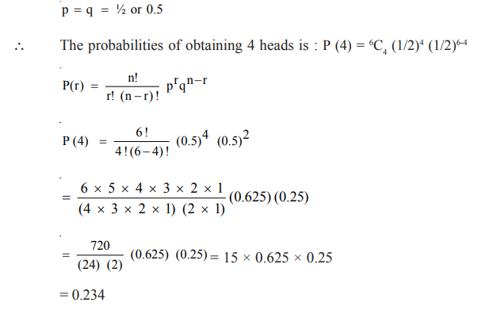

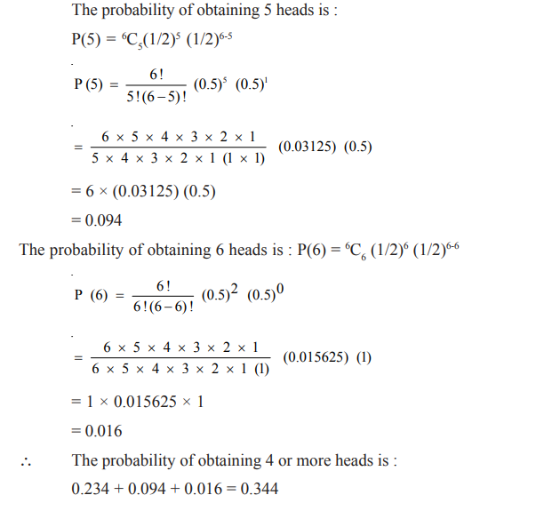

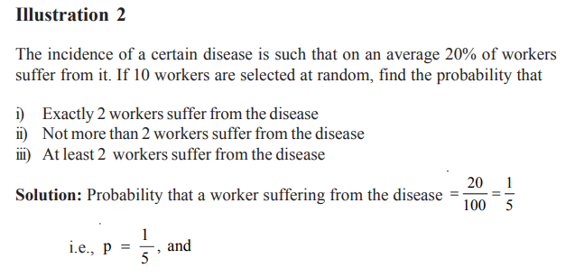
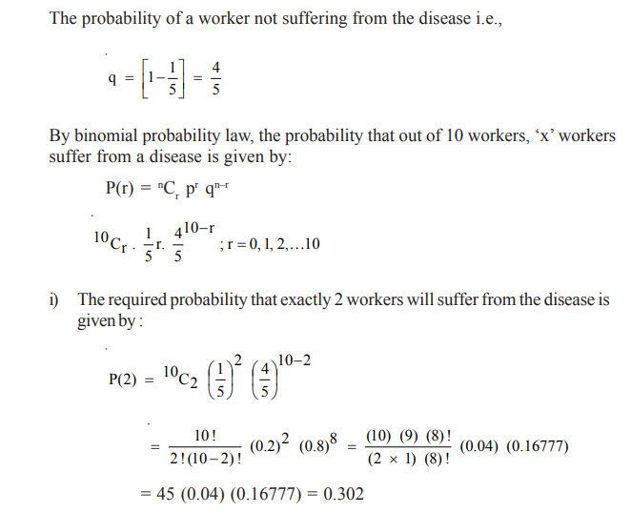
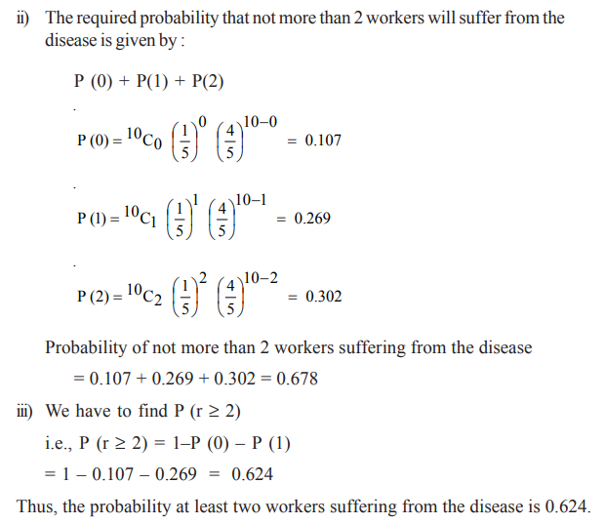
Measures of Central Tendency and Dispersion for the Binomial Distribution
As discussed in the Introduction, the binomial distribution has expected values of mean (µ) and a standard deviation (σ). We now see the computation of both these statistical measures.
We can represent the mean of the binomial distribution as :
Mean (µ) = np.
where, n = Number of trials; p = probability of success
And, we can calculate the standard deviation by :
σ = $\sqrt{npq}$
where, n = Number of trials; p = probability of success; and q = probability of failure = 1 - p
Illustration 3
If the probability of defective bolts is 0.1, find the mean and standard deviation for the distribution of defective bolts in a total of 50.
Solution: P = 0.1, n = 500
∴ Hence (µ) = np = 500 × 0.1 = 50
Thus, we can expect 50 bolts to be defective.
Standard Deviation (σ) = $\sqrt{npq}$
n = 500, p = 0.1, q = 1 - p = 1 - 0.1 = 0.9
∴ σ = 500 × .1× .9 = 6.71
Fitting a Binomial Distribution
When a binomial distribution is to be fitted to observed data, the following procedure is adopted:
- Determine the values of ‘p’ and ‘q’. If one of these values is known, the other can be found out by the simple relationship p = 1- q and q = 1- p. If p and q are equal, we can say, the distribution is symmetrical. On the other hand if p’ and ‘q’ are not equal, the distribution is skewed. The distribution is positively skewed, in case ‘p’ is less than 0.5, otherwise it is negatively skewed.
- Expand the binomial (p + q)^{n} . The power ‘n’ is equal to one less than the number of terms in the expanded binomial. For example, if 3 coins are tossed (n = 3) there will be four terms, when 5 coins are tossed (n = 5) there will be 6 terms, and so on.
- Multiply each term of the expanded binomial by N (the total frequency), in order to obtain the expected frequency in each category.
Let us consider an illustration for fitting a binomial distribution.
Illustration 4
Eight coins are tossed at a time 256 times. Number of heads observed at each throw is recorded and the results are given below. Find the expected frequencies. What are the theoretical values of mean and standard deviation? Also calculate the mean and standard deviation of the observed frequencies
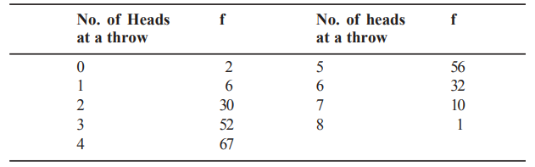

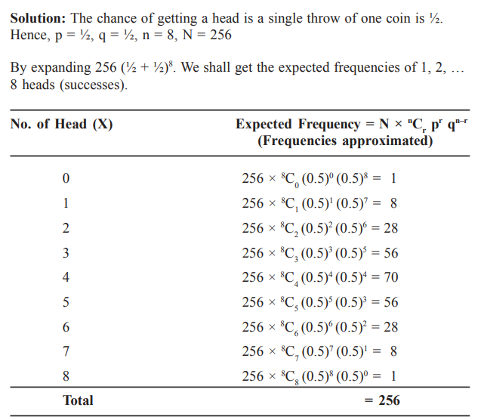
If we compare the above expected frequencies with the observed frequencies, given in the illustration, we find that the two frequencies are in close agreement. This provides the basis to conclude that the observed distribution will fits the expected distribution.
The mean of the above distribution is:
µ = np = 8×1/2 =4
The Standard Deviation is (σ) = $\sqrt{npq}$ =$\sqrt{8*\frac{1}{2}*\frac{1}{2}}=\sqrt{2}=1.414$
If we compute the mean and standard deviation of the observed frequencies, we will obtain the following values
$\overline{X}$ = 4.062; S.D. = 1.462.
Practice Questions:
- Determine the following by using binomial probability formula.
a) If n = 4 and P = 0.12, then what is P (0) ?
b) If n = 10 and P = 0.40, then what is p (9) ?
c) If n = 6 and P = 0.83, then what is P (5)?
- The following data shows the result of the experiment of throwing 5 coins at a time 3,100 times and the number of heads appearing in each throw. Find the expected frequencies and comment on the results. Also calculate mean and standard deviation of the theoretical values.
No. of heads: 0 1 2 3 4 5
frequency: 32 225 710 1,085 820 228

TEXT BOOKS
- T1 = H. K Dass, Higher Engineering Mathematics, S. Chand Publishers,3rd revised edition.2014.
- T2 = B.S. Grewal, Higher Engineering Mathematics, Khanna Publishers,42th ed.2013, New Delhi.
- T3= N. P. Bali and Manish Goyal, A textbook of engineering Mathematics, Laxmi Publications, Reprint 2008.

REFERENCE BOOKS
- R1=R. K. Jain and S. R. K. Lyenger, Advanced Engineering Mathematics ,3rd Edition Narosa Publishing House ,2004,New Delhi.
- R2 =B. V. Ramana Advanced Engineering Mathematics, McGrawHill, July2006, New Delhi.
- S.P.Gupta,StatisticalMethods,S.Chand&Sons,2017,NewDelhi,ISBN9789351610281Insiders’Guide

Video Lecture :
https://www.youtube.com/watch?v=c06FZ2Yq9rk

